4. Implement a finite-state machine for morphological parsing. In this example, we&#39;ll create a simple machine to generate plural forms of English nouns using python.
Aim: To implement a simple finite-state machine that generates plural forms of English nouns.
Procedure:
- Define a noun.
- Check its ending.
- Apply the appropriate plural formation rule.
- Display the singular and plural forms.
Code:
def plural(noun):
if noun.endswith(("s", "sh", "ch", "x", "z")):
return noun + "es"
elif noun.endswith("y") and noun[-2] not in "aeiou":
return noun[:-1] + "ies"
else:
return noun + "s"
words = ["cat", "bus", "box", "baby"]
for word in words:
print(word, "->", plural(word))
Output:
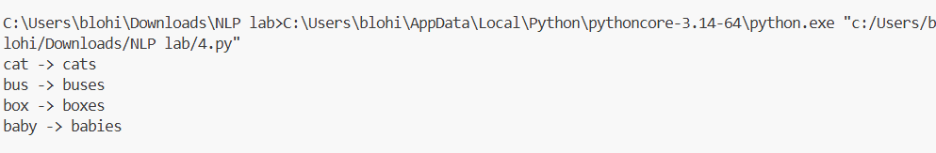
Result: A simple rule-based finite-state model was implemented to generate plural noun forms.

